Field level validation using clean methods
Field level validation is done by defining clean method within form class. For each field we define one clean method. This method is suffix with field name. It is an instance method.

Syntax:
class form-class(Form):
field-name=type
field-name=type
field-name=type

def clean_field-name(self):
validation
def clean_field-name(self):
validation

These clean methods are executed automatically whenever is_valid method of form is called or invoked.

PS C:\Users\Satish Gupta> cd D:\Backup\Django9amMar
PS D:\Backup\Django9amMar> django-admin startproject project13
PS D:\Backup\Django9amMar> cd project13
PS D:\Backup\Django9amMar\project13> python manage.py startapp app

Views.py
from django.shortcuts import render
from app.forms import StudentForm
from django.http import HttpResponse
# Create your views here.

def studview(request):
if request.method=="GET":
studform=StudentForm()
response=render(request,"stud_temp.html",context={'studform':studform})
return response
else:
studform=StudentForm(request.POST)
if studform.is_valid():
response=HttpResponse("<h2>Data is valid</h2>")
return response
response=render(request,"stud_temp.html",context={'studform':studform})
return response

forms.py
from django import forms
from django.forms import ValidationError
class StudentForm(forms.Form):
rollno=forms.IntegerField(min_value=1,max_value=100)
name=forms.CharField(max_length=20)
course=forms.CharField(max_length=20)
fee=forms.FloatField()

def clean_name(self):
name=self.cleaned_data["name"]
if not name.isupper():
raise ValidationError("Name Must be in uppercase")
else:
return self.cleaned_data['name']
def clean_course(self):
course=self.cleaned_data['course']
if course not in ["python","java","ai"]:
raise ValidationError("Course must be python,java or ai")
else:
return self.cleaned_data['course']

stud_temp.html
<!DOCTYPE html>
<html lang="en">
<head>
<meta charset="UTF-8">
<meta name="viewport" content="width=device-width, initial-scale=1.0">
<title>Document</title>
</head>
<body>
<form method="post">
{%csrf_token%}
<table border="2" width="100%">
{{studform.as_table}}
<tr>
<td><input type="submit" value="submit"></td>
<td><input type="reset" value="clear"></td>
</tr>
</table>
</form>
{%if studform.errors%}
{{form.errors}}
{%endif%}
</body>
</html>

Urls.py
from django.contrib import admin
from django.urls import path
from app.views import studview
urlpatterns = [
path('admin/', admin.site.urls),
path('studview/',studview),

]

settings.py
INSTALLED_APPS = [
'django.contrib.admin',
'django.contrib.auth',
'django.contrib.contenttypes',
'django.contrib.sessions',
'django.contrib.messages',
'django.contrib.staticfiles',
'app',
]

TEMPLATES = [
{
'BACKEND': 'django.template.backends.django.DjangoTemplates',
'DIRS': [BASE_DIR/"templates"],
'APP_DIRS': True,

Form level validation
Form level validation is nothing validating multiple fields.
For performing form level validation “clean” method of super class (Form) must be override.

Syntax:
Class form-class-name(forms.Form):
Field-name=type
Field-name=type
Field-name=type

def clean(self): # overriding method
super().clean()
logic for validating of multiple fields

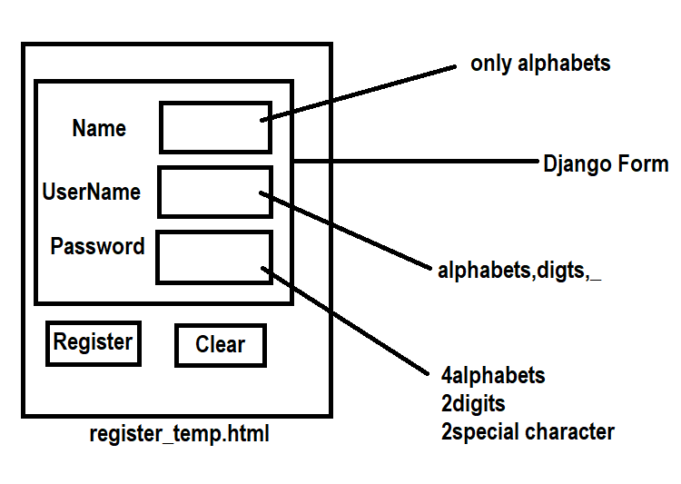

PS D:\Backup\Django9amMar> django-admin startproject project14
PS D:\Backup\Django9amMar> cd project14
PS D:\Backup\Django9amMar\project14> python manage.py startapp app
PS D:\Backup\Django9amMar\project14>

